**Vi EDITOR**

**Method to create a new file**

* cat 🡺 Concatenate
* vim 🡺 Virtual Instrument Improved
* vi 🡺 Virtual Instrument
* touch 🡺 To Create file

**Vi MODES**

* **Insert mode** – click i to enter insert mode
* **Command mode** – Default in vi editor
* **Executions** – Click (:) to execution mode

**What is the difference between Vim and Vi**

==============================================

**Vim** :- Basically 'vim' is an Text editor which opens a blank file which you can edit and save it.

By using vim editor file content can be encrypted.

**Vi** :- file content can not be encrypted.

**COMMAND MODE()**

It is default mode. In this mode we can copy, paste and delete.

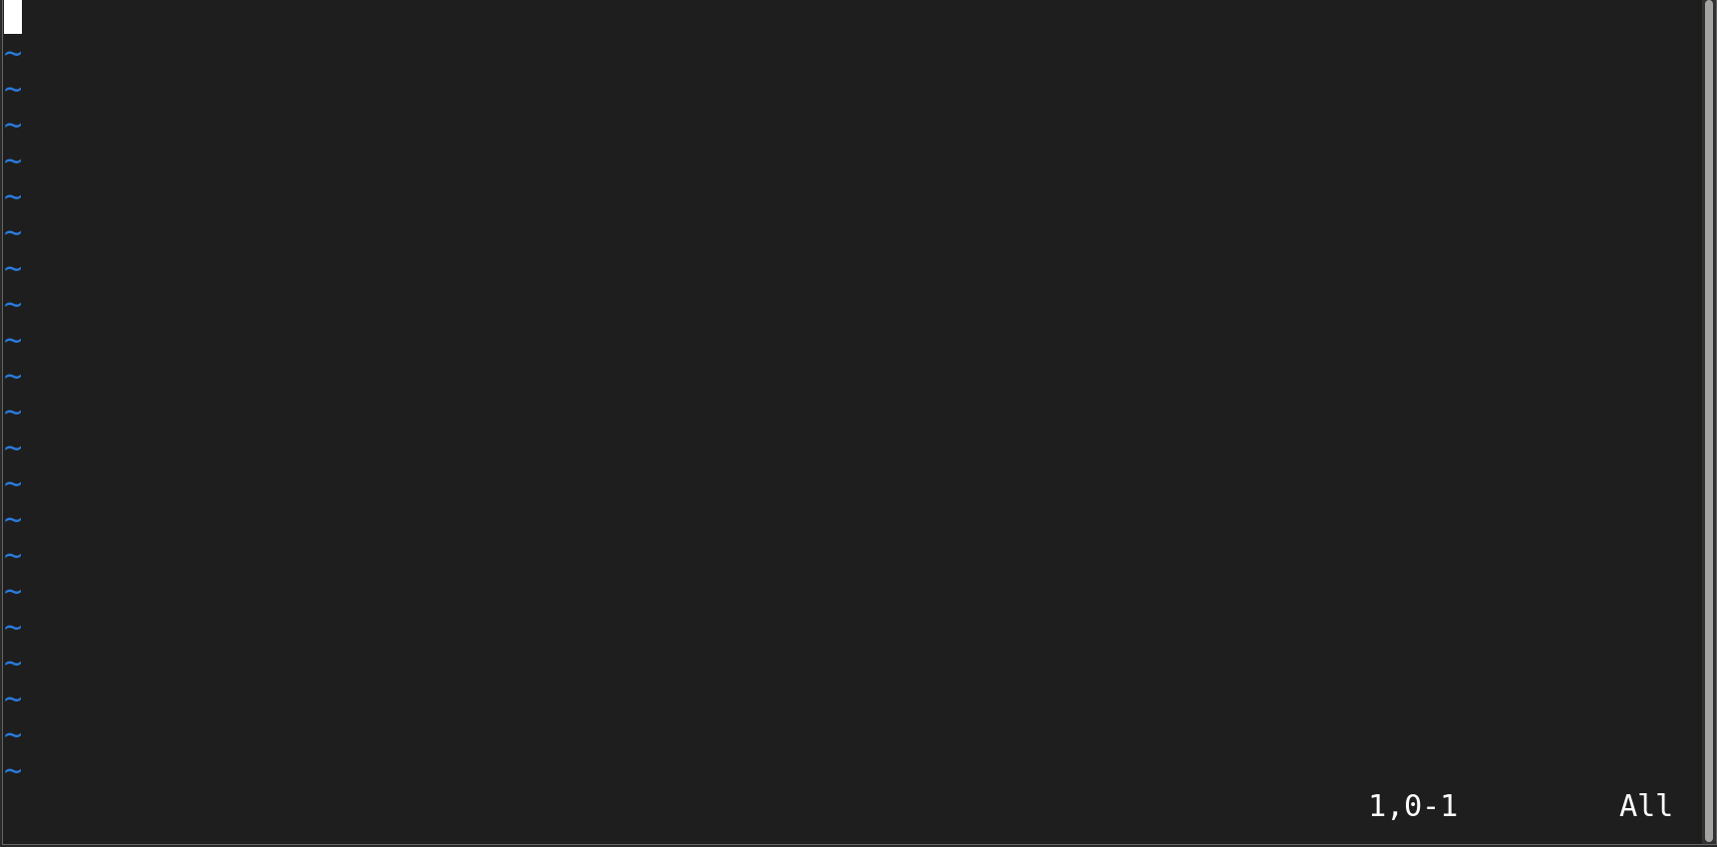

* yy 🡺 copy
* 3yy 🡺 copy 3 lines from the courser
* P 🡺 paste
* 3p 🡺 paste 3 times
* P 🡺 paste above the courser
* 4P 🡺 paste above the courser 4 times
* dd 🡺 to delete a line (or)cut
* 4dd 🡺 to delete 4 lines
* gg 🡺 move courser to first line
* GG 🡺 move courser to last line
* / (or)?word 🡺 to search word in command mode
* n 🡺 to search next
* N 🡺 to search previous
* u 🡺 undo
* ctrl + r 🡺 redo
* ZZ 🡺 save in command mode

the above all command are used in texted file.for to write the text we use the insert mode. After writing few para in file then we can use the above command to edit the file.

**INSERT MODE**

* This mode which is needed to modify the file
* Press i to Shift form of command mode to Insert mode.
* After switching the insert mode now we can text into the file.

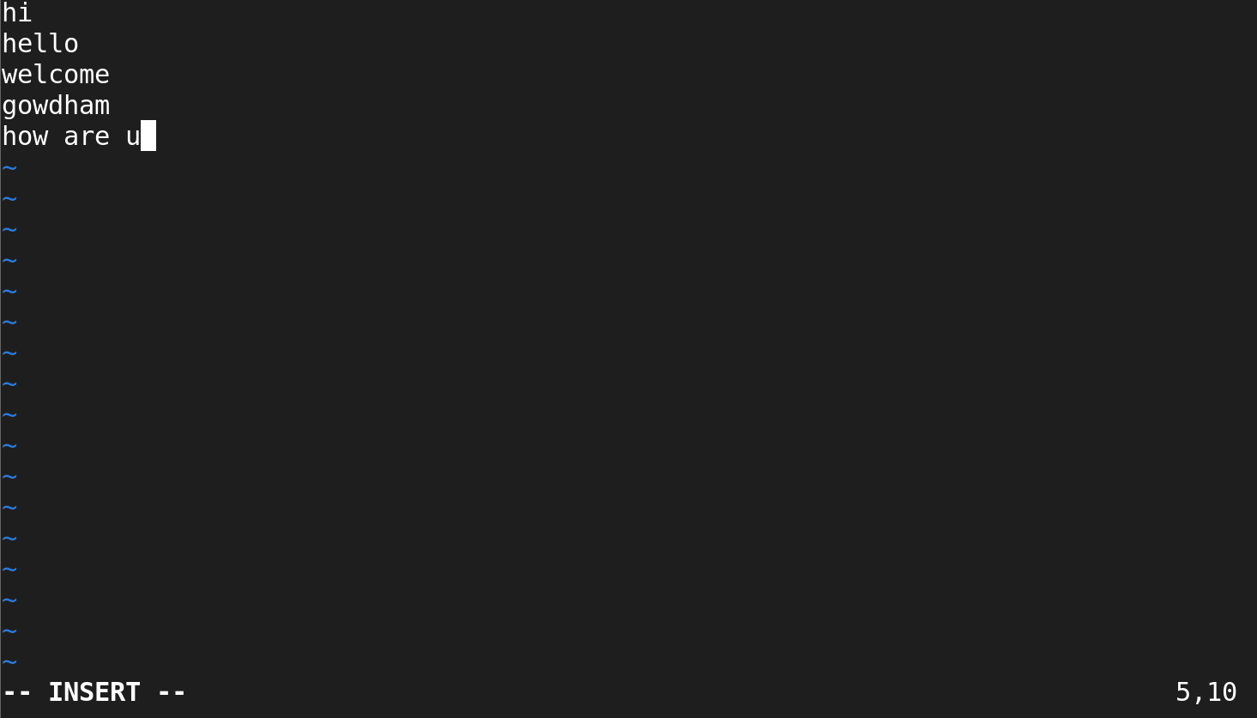

* i 🡺 To enter **insert mode**
* I 🡺 insert from **beginning** of the line
* a 🡺 insert near to courser
* A 🡺 insert last of the line to the courser
* o 🡺 insert from **below** of the courser
* O 🡺 insert from **above** of the courser
* ESC 🡺 exit from insert mode

The above all command are use to switch from command mode to insert mode keys.

**EXECUTION MODE**

Exit command mode ----> : (command)

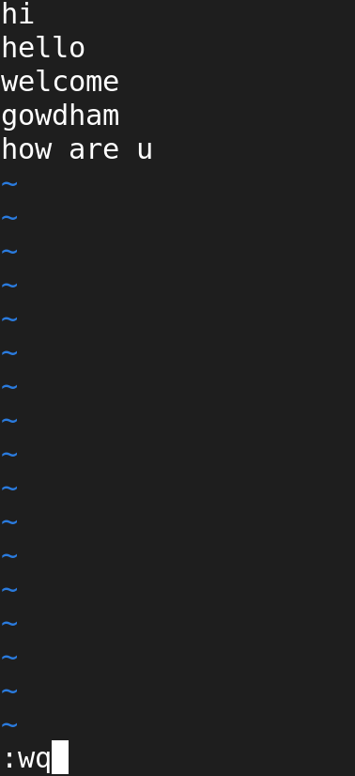

* :q --> without saving quite from file
* :q! --> forcefully quite
* :w --> save the changes
* :w! --> forcefully save changes
* :wq --> save and quite
* :wq! --> forcefully save and quite (it will modify the time stamp )
* :x --> save and quite
* :25 --> moves cursor to 25th line
* :set nu --> to set line numbers to line in the file
* :set nonu --> remove line numbers
* :5d --> delete 5th line
* :$d --> delete last line
* :3,6d --> delet 3rd line to 6th line
* :$ --> place the cursor in the last line
* :noh To exit from highlight search

TO search a word and replace it with new word

===================================

:%s/old/new/g

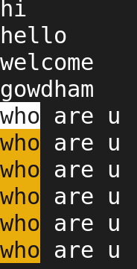 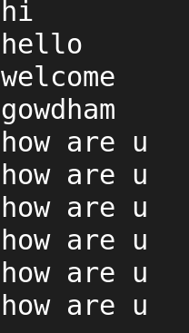

🡺**sed -e s/old/new/g filename**

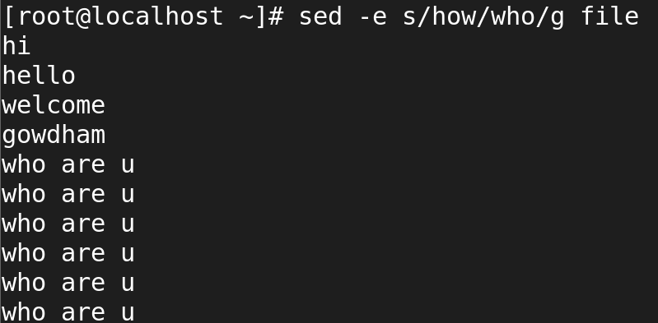

🡺**sed -i s/old/new/g filename**

